**RTC Module Documentation**

**1. Introduction**  
The RTC design for AP80 series chips is based on two 32-bit hardware registers: a counter register Cnt and an alarm register AlarmCnt, with seconds as the counting unit. The 32-bit width supports approximately 136 years of counting, fully meeting practical requirements. The supported range is from 00:00:00 on January 1, 1980, to 23:59:59 on December 31, 2099.

Only one hardware alarm is available, but through software methods, the system can support any number of concurrent alarms. The current alarm register only loads the alarm time closest to the current time. When that alarm triggers, the next closest alarm time is loaded, and so on—similar to "time-division multiplexing."

The RTC clock source originates from a 32k crystal oscillator, whose accuracy directly determines the precision of the RTC clock.

The AP80 series RTC module provides the following features:

●  Clock: Hardware-dependent implementation.

●  Alarm: Hardware-dependent implementation.

●  Lunar Calendar: Pure software, hardware-independent, converts Gregorian dates to lunar dates.

●  Support Low-power mode.

**2. Typical Applications**  
After power-on, the system must call RTC_Init(uint8_t* AlarmBuffer, uint8_t AlarmBufferSize) to initialize the RTC, allocating memory based on requirements such as alarms and lunar calendar functionality.

**Clock Setting Procedure**

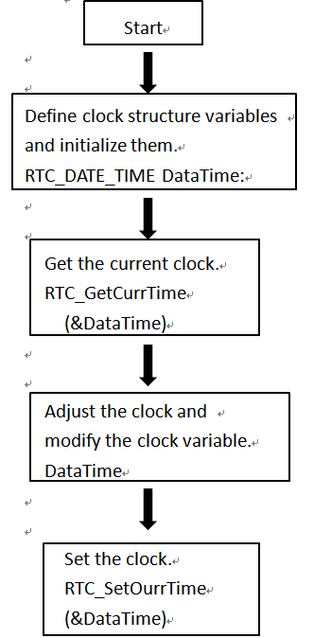

**Alarm Setting Procedure**

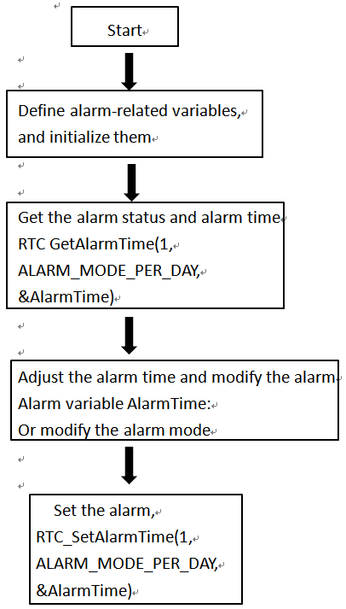

**Alarm Response Handling Procedure**

Start

Set alarm

N

Alarm arrived

RTC_CheckAlarmFlag()

Y

Alarm handling function

RTC_AlarmArrivedProcess()

Customer needs to

handle alarm response